 | Mandatory | Uniqueness | Frequency | Ring | Subset | Exclusion | Equality
Mandatory | IMPLEMENTED   Subset Implies  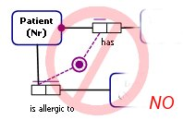  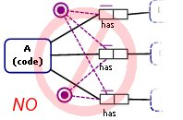They are not saying the same thing but one of them needs to go | Shouldn’t contradict; mandatory is irrelevant to uniqueness  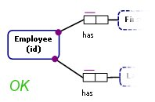  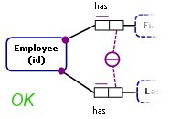 |  |  | 
Uniqueness |  | IMPLEMENTED   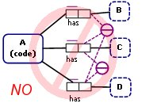  Subset Implies  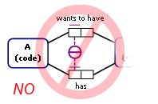  Internal uniqueness constraint implies external one | 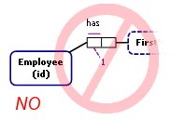  Redundant  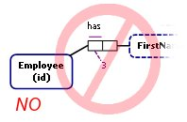  The role cannot be unique if it has to be played 3 times
Frequency | Shouldn’t contradict; mandatory is irrelevant to frequency  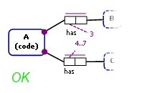 |  | 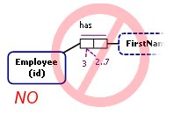  Overlap  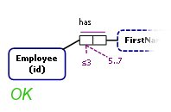  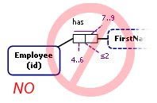  The overlap will be at least 4
Ring | Shouldn’t contradict | Shouldn’t contradict | Shouldn’t contradict | 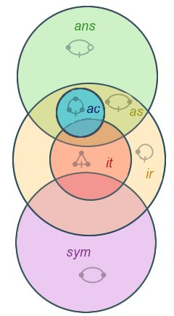  The ones that do not overlap 100% can be put together on one set of roles; the ones that do not overlap cannot be put together; when ring type A is contained by another ring type B – A implies B but not the other way around | Does it make sense to put a subset constraint on a ring fact type?  (Yes, there is. Consider a case of Subset-Irreflexive)  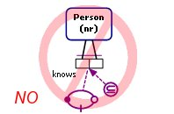  …if it does, the above it incorrect because for a population p:  A B  B A  A A  p satisfies subset constraint, but B–A violates antisymmetric. |   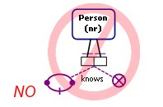  Implied  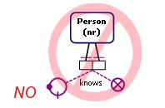  Implied
Subset | IMPLEMENTED   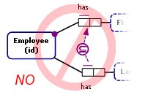  Implied subset relationship  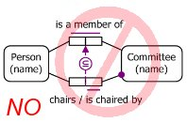  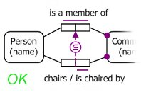 | 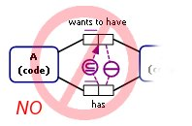  Implies Internal Uniqueness on the lower role. Since stronger (Internal) constraint must appear instead of the weaker (External), this must result in Implication Error. | 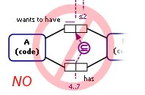  Would always contradict unless the frequency on superset is greater than the frequency on the subset |  | 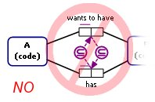  Implies equality  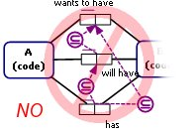  Third subset is implied  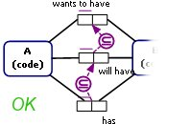 | IMPLEMENTED   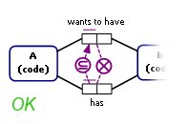  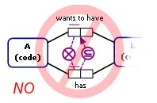
Exclusion | IMPLEMENTED   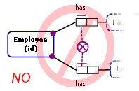  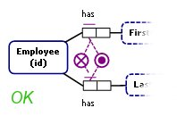  NOTE: MAKE SURE DISJUNCTIVE WORKS  PROBABLY NEED A SPECIALIZED ERROR FOR WHEN THERE’S ONLY ONE MANDATORY |  |  |  |  | Subset implies  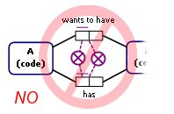  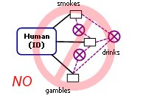  2 of them are implied  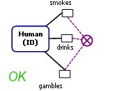  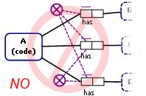  They are not saying the same thing but one of them needs to go
Equality | IMPLEMENTED   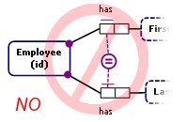  Implied  NOTE: CURRENTLY THERE’RE 2 PLACES THAT VALIDATE THIS CASE AND 2 ERRORS THAT ARE PRODUCES (OLD CODE AND NEW ONE NEED TO BE MERGED) | Shouldn’t contradict | 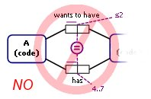  Would always contradict unless the numbers on sets being compared are the same | 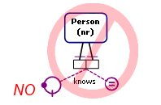  Contradicts  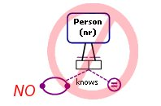  Implied | IMPLEMENTED   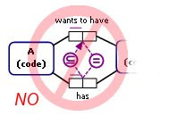  Equality implies subset relationship; equality is stronger | IMPLEMENTED   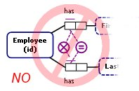  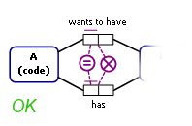  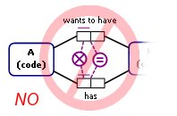  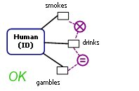  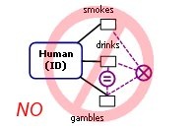  Really, 3-role-sets sequences would follow same principles | Equal Sets Contradict

